**BFBS Inter Services XC MTB 2021, Wed 29 Sep 21, Woodbury Common**

**Army XC MTB Team Race Report**

The 2021 BFBS Inter Services Cross Country Mountain Bike (ISXCMTB) event took place at Woodbury Common on Wed 29 Sep 21, hosted by the Royal Navy. A superb course that offered great single-track, rewarding climbs and technical descents awaited.

The Army Team were in good spirits, having had a strong, delayed start to the season all riders where at peak fitness and also gave strength in depth, (offering the Team Manager (Capt Will Matthews) significant talent to draw from) to defend the title won in Aldershot back in 2019 (CV19 cancelled the 2020 event).

**Venue Recce** With the South West location being a significant distance for the majority of the team, it was decided that to facilitate Course Orientation (time spent on reconnaissance seldom wasted!) the team would travel to the venue the day prior to shake out as a group, and support each other with bike setup (tyres, tyre pressures, suspension setup, bike selection and iron out any potential reliability issues).

This option became viable thanks to ASCB assistance, with funding for the team being released for accommodated in a nearby B&B (continued CV19 regulations and lack of Unit availability for accommodation resulted in non-availability). This would also facilitate adequate wellness to the team in terms of rest and stress levels for race day and lend itself to a group evening meal the evening before race day to discuss future plans in a relaxed environment.

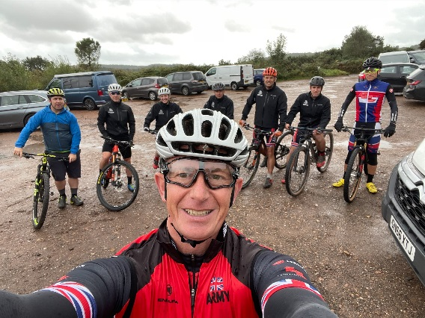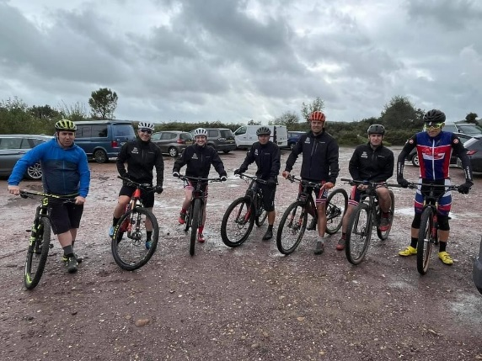

Anyway, back to the ‘race recce’ – What can only be described as a ‘biblical downpour’ greeted us on arrival but undeterred we all donned our finest Endura waterproof equipment and headed out on course. Lots of technical features where ‘sessioned’ (the repeated riding of a segment, watching / coaching each other before selecting & then perfecting race lines across a technical feature, downhill or uphill) before riding a couple of full laps. During these laps, the team rode well within their potential, to keep legs and lungs fresh for race day.

Content we where all now sufficiently wet and muddy, we headed back to the sanctuary of the carpark, and (a lot!) of G1 to sort ourselves and equipment ready for the main event. It did not escape my attention that having a hotel nearby was also a winning decision for our long-suffering partners, having personally received the wrath of ‘Zero Alpha’ when trying to sneak a muddy bike and clothing into the house.

Handily, all riders had brought good supplies of the excellent Fenwicks range of bicycle maintenance products, which proved invaluable in the significant clean-up operation that followed and would also ensure our equipment was in tip top condition for the next day

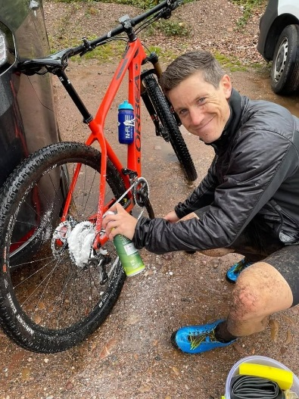 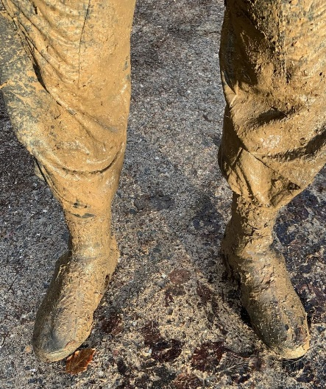 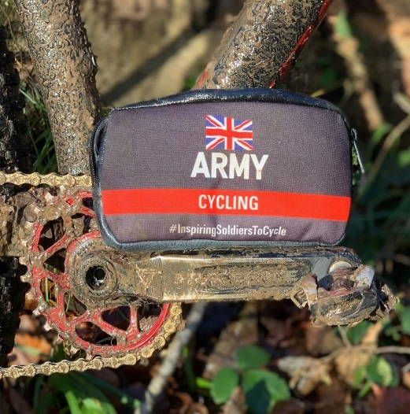

The evening offered an opportunity for members of the team to gather and discuss plans for the forthcoming season, very much a ‘look forward to’ (now that the pandemic is drawing to a close) with lots of exciting events for 2022 and beyond. It also gave us the chance to discuss coaching, mechanic qualifications and so on to make the team more robust and self-reliant for the future. Then it was onto race day tactics, with serious chat along with occasional lighthearted ribbing of each other, our plan was set. We recognised the ISXCMTB overall title as a ‘team event’ and that whilst individual glory is a fantastic achievement, the main effort was retaining the title as Team Champions.

Our plan was simple – pack the top 15 with as many riders as we could, to hunt and pass competitors and then hold station where possible, and not attack each other. Support and communication was the order of the day.

Another factor for consideration was a 30point penalty for any rider that had a DNF, so with 13 riders registered in the Army Team and ‘XC racing being XC racing’, the odds appeared challenging but as always in racing, same conditions for everyone. Bike checks and kit preparation was also high on the agenda, in an attempt to ‘control the controllable’.

With that in mind, the team retired for the evening and dutifully prepared themselves mechanically, physically and mentally.

**Race Day** A glorious sunny day greeted the riders onto the course, in stark contrast to the previous day’s conditions. The team kitted out whilst the Team Manager confirmed registrations at race control, before then handing out the race numbers. The hosts had arrived in force, along with a healthy amount of RAF riders it was apparent that competition would be fierce, and no quarter given.

We all headed onto the now taped up / marked out course and were immediately impressed with how well the course flowed, but aware that mud and wet roots meant 100% focus, always. Easy to say, and difficult to maintain at race pace for over an hour, concentration and focus would be essential.

We were also delighted to see Colonel Richard Smith RA in attendance , complete with wellies and hound, who had come along to cheer us on and observe as ACU Chairman. No pressure!

**Pre-Race Brief** A Royal Navy PTI Course was running concurrently, so the event provided a great opportunity for the students to provide the administrative function and they did it superbly. A comprehensive safety brief and a positive can-do approach to any questions we had all contributed to the smooth running of the event.

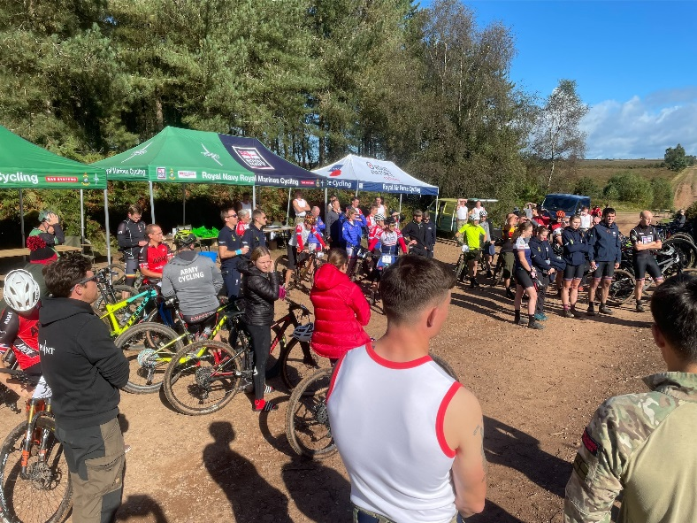 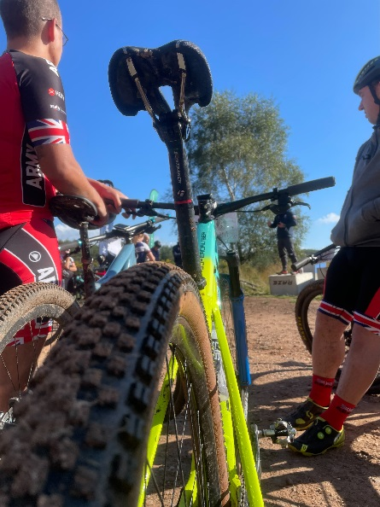

**The Race** Our respective teams of riders lined up, having been ‘seeded’ by Team Managers. So, each of our top riders on the front row, and then working back on respective rows. The start was a wide gradual gravel-based climb that led out over 400mtrs, before turning right and the charge for the single-track positioning began with gusto.

At 1200hrs, the flag dropped, and it was a predictably rapid start, with no team giving each other an advantage and elbows out to protect lines. Looking across the group as we hit the first turn, Team Army were in strong positions across the field and marking competitors smartly. Major Si Richards, WO2 Gordy Eastman and Sgt James Bevan where well up in the top placings for Army, with Lt Col Alex Ficke, SSgt Rob Craig, SSgt Si Brummett and an impressive late call up by SSgt Sam Green all supercharging the midfield.

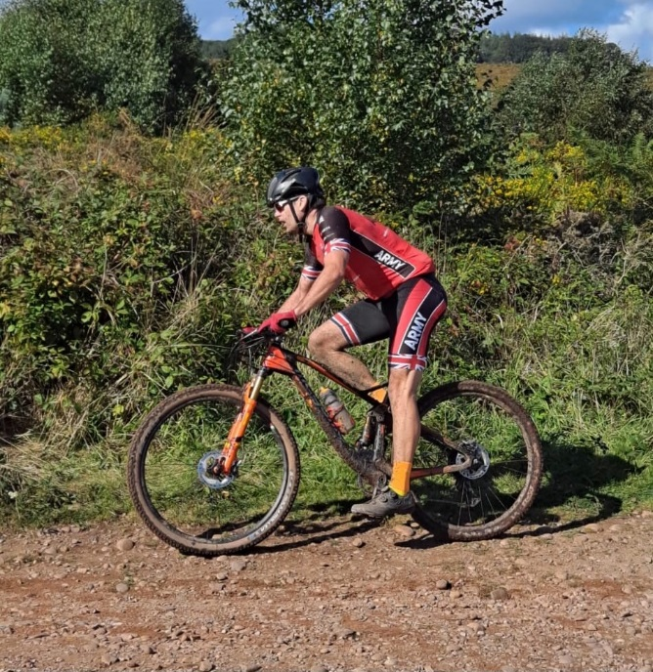 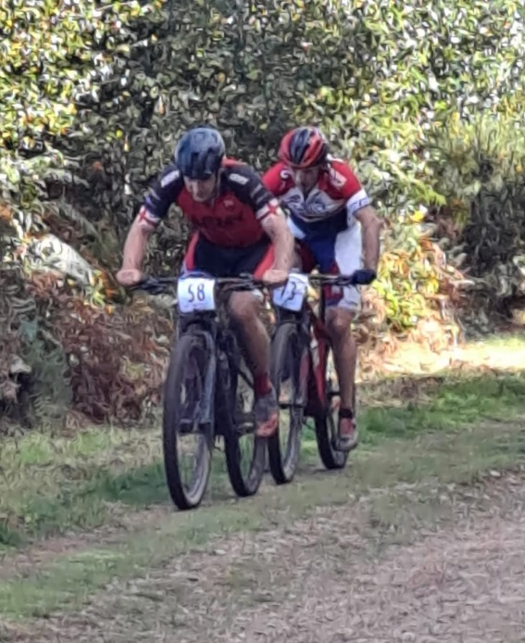

Major Si Richards SSgt Rob Craig fending off an RAF Rider

In the lady’s category, newly commissioned 2Lt Amy Drysdale, Maj Ang Laycock and Cpl Chloe Weller were all working superbly as a group to fend off their service rivals and where powering along nicely.

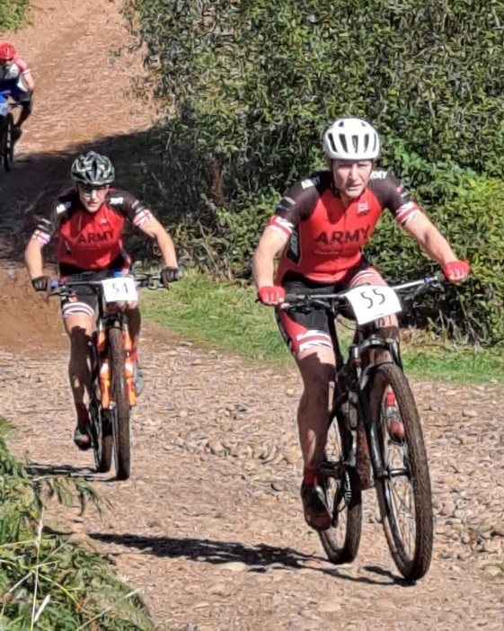 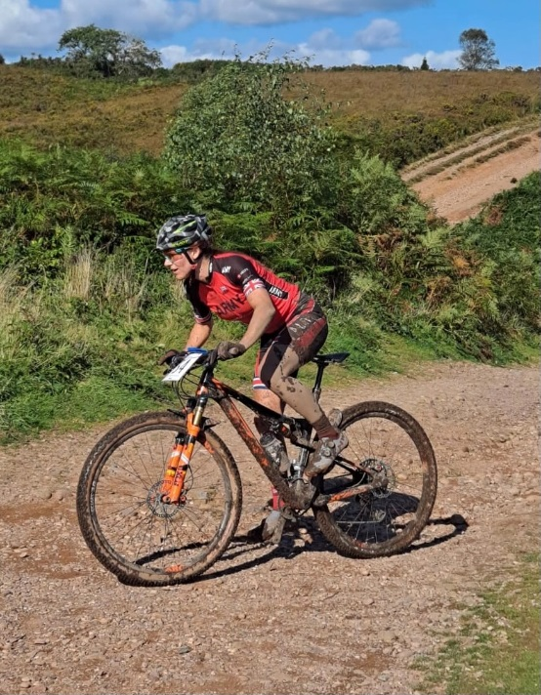

2Lt Amy Drysdale Maj Ang Laycock

The Team Manager Capt Will Matthews and the Team Mechanic, LCpl Walsh both competed and rode as hard as they could whilst concurrently assisting as reqd and providing updates and encouragement to the team at the sharp end. Sgt Willow Willis, another very late addition to support the team rode a superb race to protect the riders ahead of him, everything we asked for.

Colonel Richard awaited at the bottom of a descent, giving us all updates and providing much appreciated encouragement, easily adding another 50watts per rider as we tackled the challenging loose climb just ahead and fighting past competitors.

As the designated 5 laps of the course passed, an impressive ride by Aled Jones of the Royal Navy saw him take overall individual victory, with Dan Lewis and James Whitworth of the RAF taking 2nd and 3rd. Our first Army rider came home 4th (Maj Si Richards) with WO2 Gordy Eastman and Sgt James Bevan following him over the line.

Our plan of contesting all places appeared to have been the right one, with the Navy finishing well and perceived to be our biggest threat overall.

**The Result**

In the lady’s category, an impressive ride from 2Lt Amy Drysdale saw her become ISXCMTB Champion 2021, with Maj Ang Laycock following her home and onto the podium. Cpl Chloe Weller was not far from the podium, looking strong and most importantly, making it to the finish.

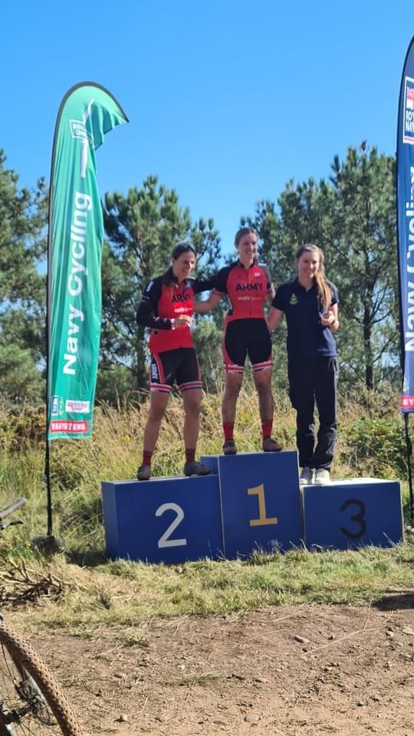**Female Individual Category Podium**

3RD Katie Pratt Royal Navy

2nd Maj Ang Laycock Army

1st 2Lt Amy Drysdale Army

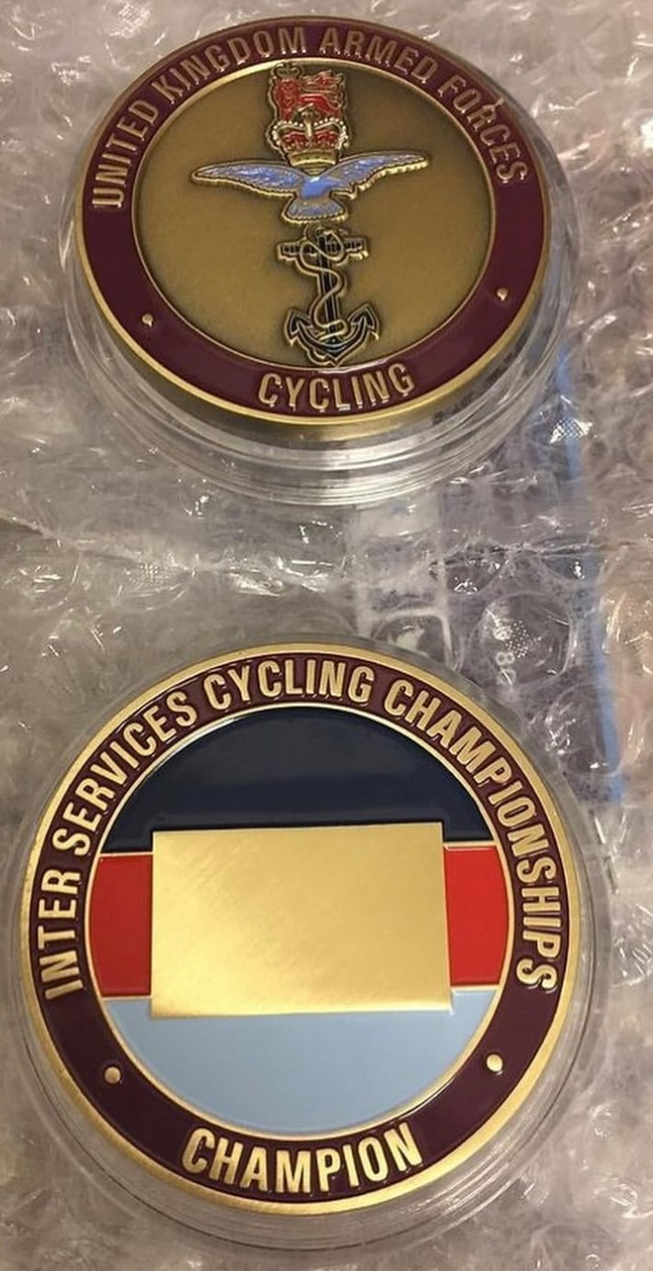

**ISXCMTB Team Champions 2021**

As the scores where collated, a sense of excitemnet and nerves spread across the team, had we done enough? The Royal Navy had pushed us close, the RAF took 2nd and 3rd in the Mens Individual, could we be the Team Champions and defend our title? In the end, with RAF third and Royal Navy coming a superbly fought second, a great cgheer went across the Army Team and we where delighted to be recognised as the 2021 ISXCMTB Champions. A fantastic trophy has also been produced and was produdly received at the podium:

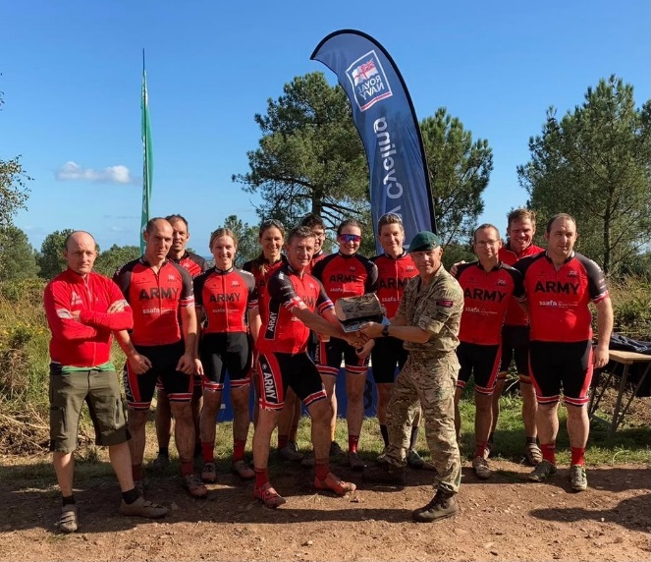

**Inter Service Cross Country Mountain Bike Champions 2021**

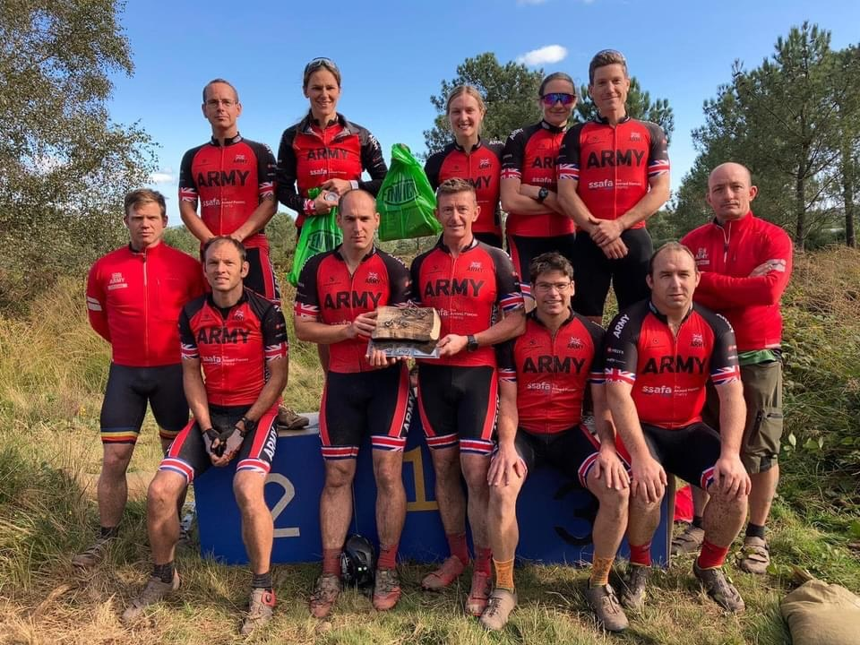

**Top L To R**: WO2 Eastman, Maj Laycock, 2Lt Drysdale, Cpl Weller, Sgt Bevan

**Bottom:** SSgt Green, SSgt Brummett, SSgt Craig, Capt Matthews (Team Manager), Maj Richards (Team Captain), LCpl Walsh (Team Mechanic), Sgt Wilson

**Looking to the future** Team Army competed at this prestigious event and every rider stood up to be counted. A fantastic course and superb competition. It was also noted that a Development race was organised in parallel to the IS Event. I propose to ACU that the top 10 individuals in each category of the ACU Inter Corps XC Series be invited to come and compete on the Course, as additional recognition for their series achievements, and to showcase their potential to the Army XC MTB Team Manager for the following season.

**Summary** A successful defence of the ISXCMTB Title, by a team that gave absolutely everything to represent the Army Colours. We look forward to the 2022 event, hosted by the RAF and expect it to be even more hotly contested, so we must rest on our laurels. For now, we will enjoy the moment before we go back to the basics and prepare for the forthcoming season. We wish to thank ASCB along with all supporters and sponsors of the Army XC MTB Team, it is hugely appreciated.

{Original Signed}

Capt Will Matthews

Army XC MTB Team Manager